

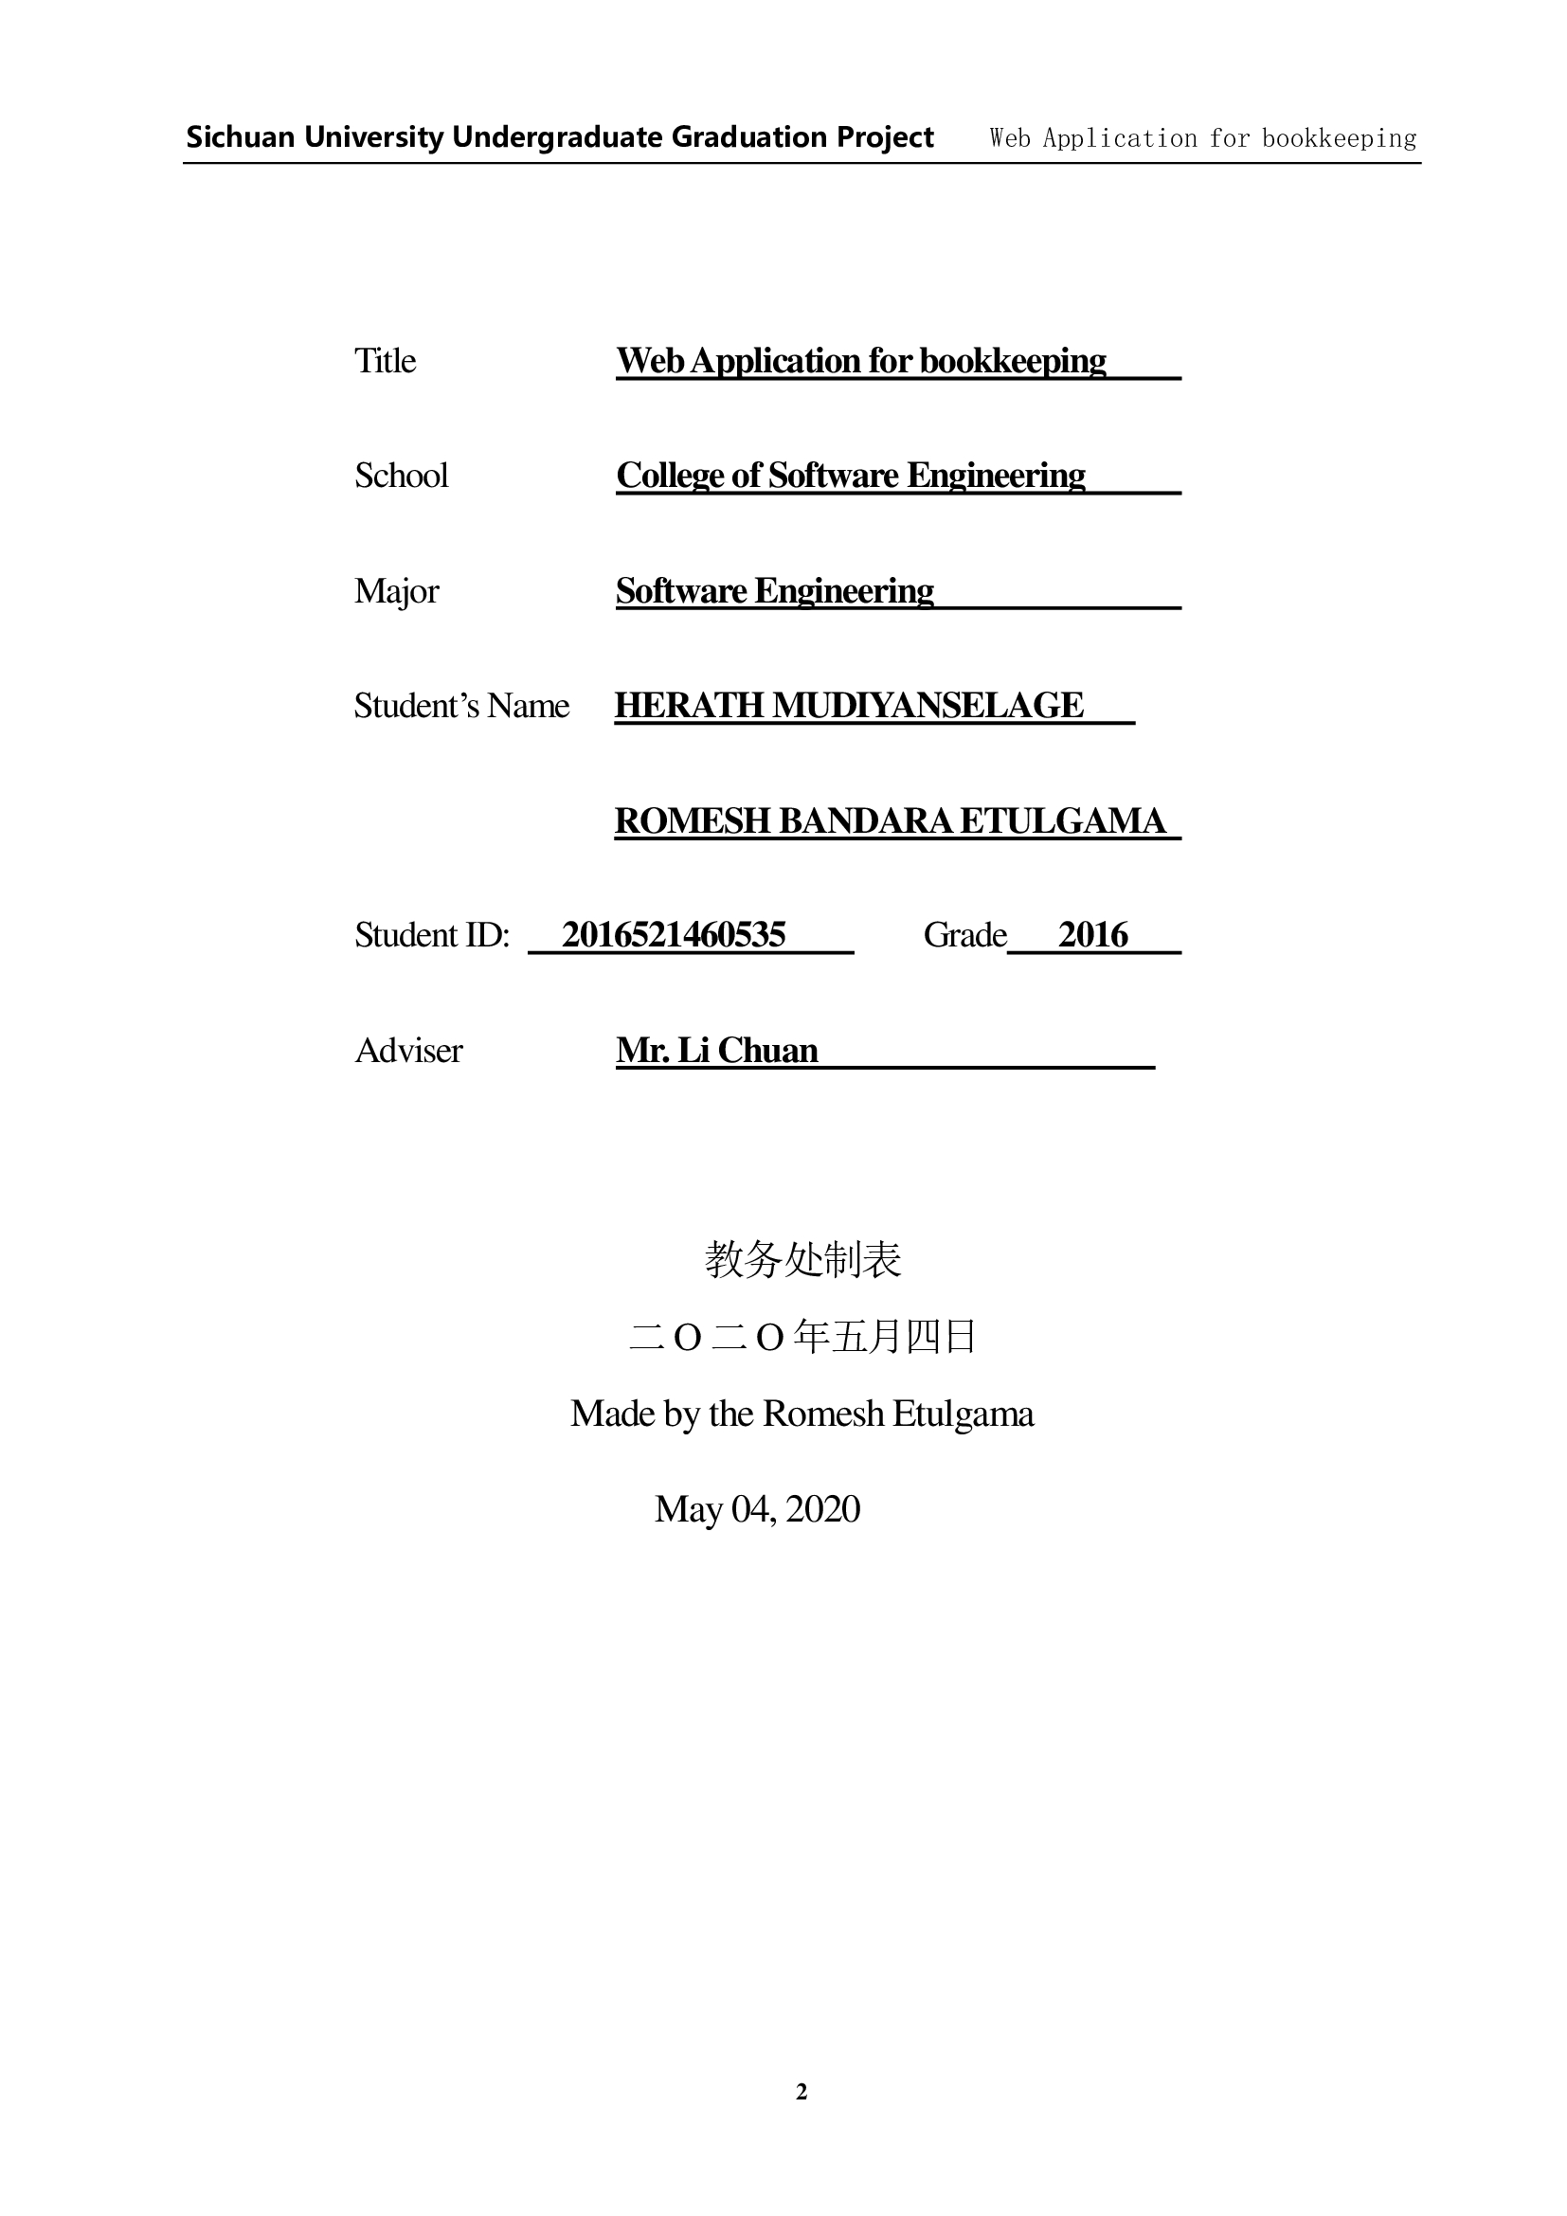

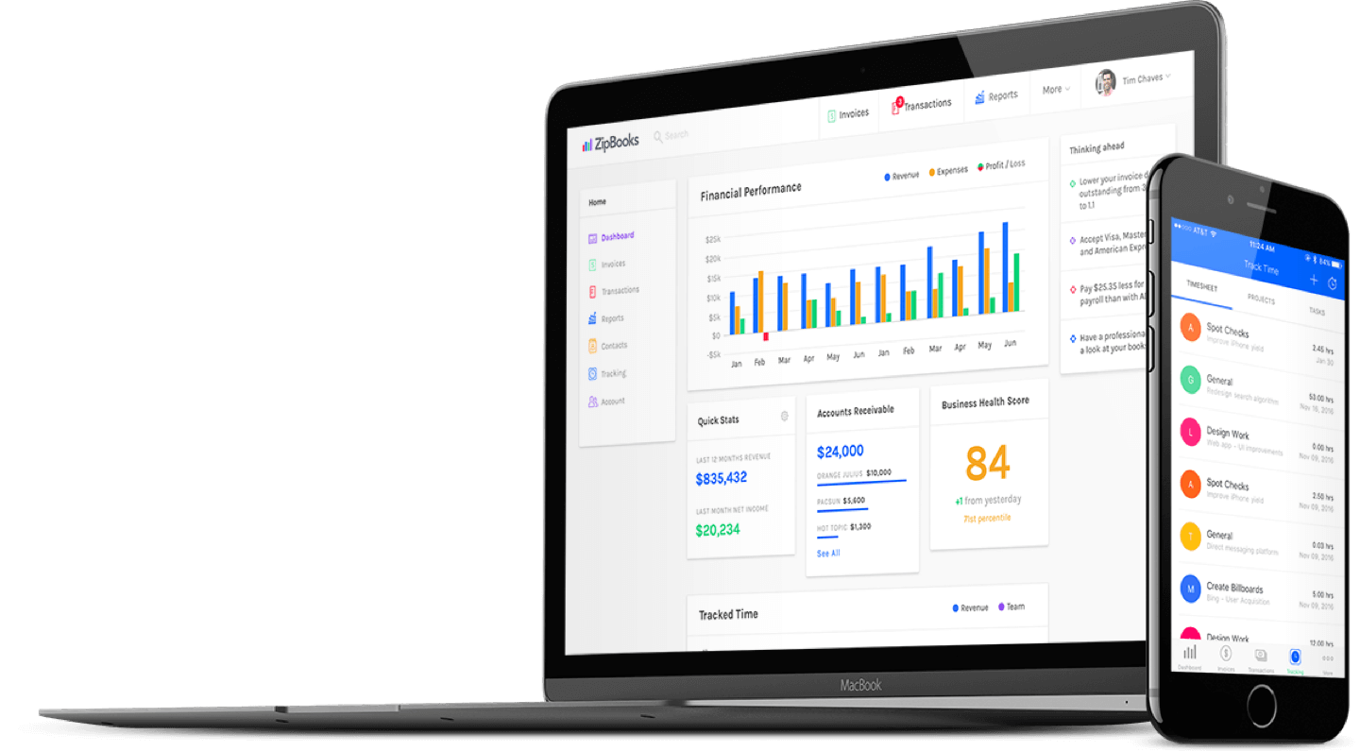



BOOKKEEPING web APPLICATION

Romesh Etulgama (2016521460535)

| Capstone Project |

Under supervision of Mr. Li Chuan

Software Collage - SICHUAN UNIVERSITY

26-04-2020

# Abstract

This report describes the project development of the Bookkeeping web application, "Quentin" that was developed to manage the daily transactions and manage the clients, inventories, sales and accounts more efficiently. This application is mainly used by the clerks, managers and the CEO of the company. A clerk is able to manage the suppliers, inventories, production, sales and financial transactions in the company as well as the factory itself. Besides that, the application allows the user to generate various kinds of reports such as client information, historical reports plus reliable forecasts to help the entrepreneurs make better decisions.

The methodology I used to develop this system is waterfall model. Thus, the report's chapters include system planning, requirement analysis, system design, programming, system testing, and evolution of the project. For the system planning, the outcomes are the project objectives and project aim as well as to define the project scope. Requirement analysis is a stage to gather the user requirements such as functional requirements and non-functional requirements. Next the system design is mainly used to design the user interface and the database design. The next stage after system design is programming stage. This is the stage for coding. After completion of the coding part, I proceeded to the system testing to minimize the bugs in the systems.

Compared to the existing manual methods used by the target company, this system has many strengths and fairly small amount of weaknesses such as requirement of general computer literacy. In the future, we can enhance the system with smart technologies to make it better.

Keywords: Bookkeeping, Accounting, Management, Small Businesses,

# Acknowledgements

After completing my capstone project, I would like to take this chance to express my sincere gratitude to my project supervisor Mr. Li Chuan who has guided me a lot throughout the project development.

Lorem ipsum dolor sit amet, consectetuer adipiscing elit. Maecenas porttitor congue massa. Fusce posuere, magna sed pulvinar ultricies, purus lectus malesuada libero, sit amet commodo magna eros quis urna. Nunc viverra imperdiet enim. Fusce est. Vivamus a tellus. Pellentesque habitant morbi tristique senectus et netus et malesuada fames ac turpis egestas. Proin pharetra nonummy pede.

Mauris et orci. Aenean nec lorem. In porttitor. Donec laoreet nonummy augue. Suspendisse dui purus, scelerisque at, vulputate vitae, pretium mattis, nunc. Mauris eget neque at sem venenatis eleifend. Ut nonummy. Fusce aliquet pede non pede.

Suspendisse dapibus lorem pellentesque magna. Integer nulla. Donec blandit feugiat ligula. Donec hendrerit, felis et imperdiet euismod, purus ipsum pretium metus, in lacinia nulla nisl eget sapien. Donec ut est in lectus consequat consequat. Etiam eget dui. Aliquam erat volutpat. Sed at lorem in nunc porta tristique.

Proin nec augue. Quisque aliquam tempor magna. Pellentesque habitant morbi tristique senectus et netus et malesuada fames ac turpis egestas. Nunc ac magna. Maecenas odio dolor, vulputate vel, auctor ac, accumsan id, felis. Pellentesque cursus sagittis felis. Pellentesque porttitor, velit lacinia egestas auctor, diam eros tempus arcu, nec vulputate augue magna vel risus. Cras non magna vel ante adipiscing rhoncus.

Table of Contents

Abstract 1

Acknowledgements 2

Table of contents **Error! Bookmark not defined.**

1.0 System Planning 1

1.1 Project Aims and Objectives 1

1.2 Background of the project 1

1.3 Project Scope 2

1.3.1 Milk Collection 4

1.3.2 Employee Management 5

1.3.3 Inventory Management 7

1.3.4 Sales Tracking 8

1.4 Project Schedule 10

1.5 Outline of approach / Methodology Used 11

1.5.1 Development Environment 12

1.6 Operation Environment 13

1.7 Chapter 1 Conclusion 13

Chapter 1

**System Planning**

# System Planning

The development process of the system will be discussed in this chapter as well as the system objectives, scope and schedules.

## 1.1 Project Aims and Objectives

The project aims and objectives that will be achieved after completion of the system are discussed here. The succession of the system will also be evaluated through this sub chapter.

The project objectives are:

* To eliminate/reduce the paper work in the company
* To record every transaction in computerized system so that problems occur by human error can be greatly reduced
* To implement smart technologies to the system
* To design a user-friendly graphical user interface which suits the users
* To complete the system according to the project schedule
* To produce technical reports that documents the phases, tasks and deliverables in the project

## 1.2 Background of the project

"Quentin" is a management system developed geared mainly toward small and medium-sized businesses and offer cloud-based accounting and management applications that handle the primary bookkeeping functions of a company and manage payments and payroll functions, manage asset collections, track distribution, manage relationships with their clients and more importantly to make predictions on sales.

This application is designed and implemented for a candy manufacturing company in Sri Lanka. It is a medium sized enterprise based in a rural area of the country. Most of the design aspects of the Quentin system is focused on the requirements of this particular company. The company use Cow's Milk and Sugar as the raw materials of the manufacturing process (figure 1).

Milk is collected from the rural milk suppliers, twice every day. Collection happen at the factory premises for some supplies, as well as at supplier's own farm premises by employees of the company. Usually, around 500 liters of milk is collected every day from around 40 suppliers.

Sugar is purchased from an importer and gets delivered to the factory premises.

Manufacturing process takes place by around 20 workers and some machinery, usually around 10 hours a day, 5 days of the week. Manufactured candy is called "Milk Toffee" and after the quality controlling is passed, they are packaged. The custom designed packages are purchased from a printing company which takes at least 2 weeks to deliver the empty packages after an order is placed. Therefore, it is crucial for the company to foresee the upcoming requirement and manufacturing capacity of the factory so that they can have a hassle-free workflow.

The manufactured products are then delivered to both distribution agents as well as distributed to some outlets by the company itself. Usually, the money is collected once they deliver, but some clients prefer to transfer the money to the bank or paid by a credit cheque. Therefore, the company needs to maintain an outstanding balance for individual clients.

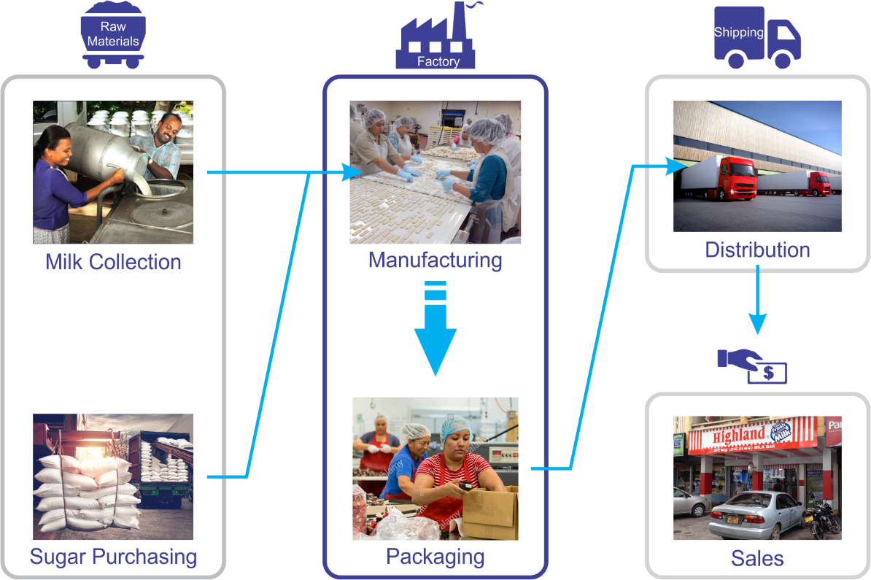

Figure 1 : Company Workflow

This application is mainly used by the clerks, managers and the CEO of the company. A clerk is able to manage the suppliers, inventories, production, sales and financial transactions in the company as well as the factory itself. Besides that, the application allows the user to generate various kinds of reports such as client information, historical reports plus reliable forecasts to help the entrepreneurs make better business decisions.

Since all of the calculations, report generation and the ability to check real-time status makes the work of the users much easier narrowing down the entirety of their workload into just recording the correct data.

## 1.3 Project Scope

The modules contained inside the bookkeeping application will be discussed below.

For the "Quentin" system, it has a web application as the front-end user interface while the back-end of the system takes care of the data validation and database management on the server.

The modules can be divided into some categories as they serve for each purpose within the system. (figure 2)

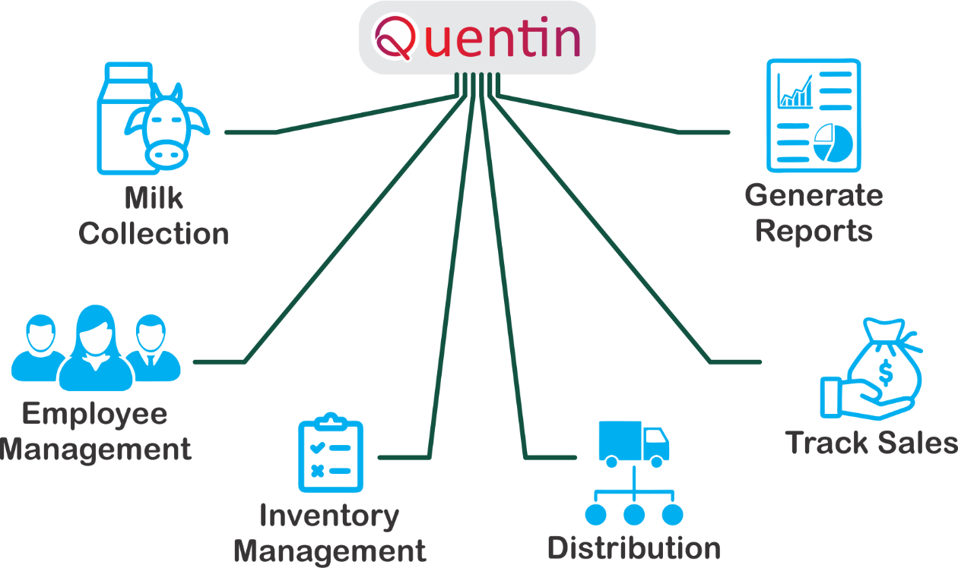

Figure 2 : Tasks handled by Quentin

**Milk Collection** – keeps track of collected milk volume from each supplier as well as generate reports so that the user can examine the trends for the near future of the milk supply.

**Employee Management** – there are four basic classes of workers employed in the company. Factory workers, Drivers, Milk Collectors and Salesmen. Each class has their own salary grade scale while each employee in a group may have its own method of calculation according to their seniority.

**Inventory Management** – purchased items including electricity, water, gas, raw materials and manufactured products are recorded in this module.

**Distribution** – This module takes care of route planning so that the delivery vehicles can have an efficient distribution and meet an exceptional result which will be discussed later in the document.

**Sales Tracking** – A profile for each client is generated in order to track their sales

**Report Generation** – All sorts of useful information is represented by the reports from daily scope to yearly scope as well as for individual aspects.

Beside the above listed modules, some other mandatory modules are also being used but I am not going to explain them much since they are common in applications like this.

#### Authorization and authentication module

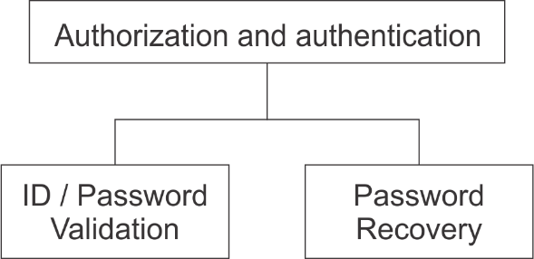

Figure 3 : Authorization and authentication module

Anyone willing to access the website needs to go through this module. They need to login to the system using their id and password. Various users can access the different modules when logged in successfully. For example, only admin level users are able to access the report module.

### 1.3.1 Milk Collection

Milk collectors goes to the milk suppliers and farms twice every day. The collected milk containers are brought back to the factory, measured and quality is tested in factory then the results are recorded on a note book. That data is then fed to the Quentin system every 15 days. The system generates a summary report for the time period (typically 15 days), a receipt confirmation chart (to be signed from the supplier), a payment breakdown chart (to be handed over to the supplier).

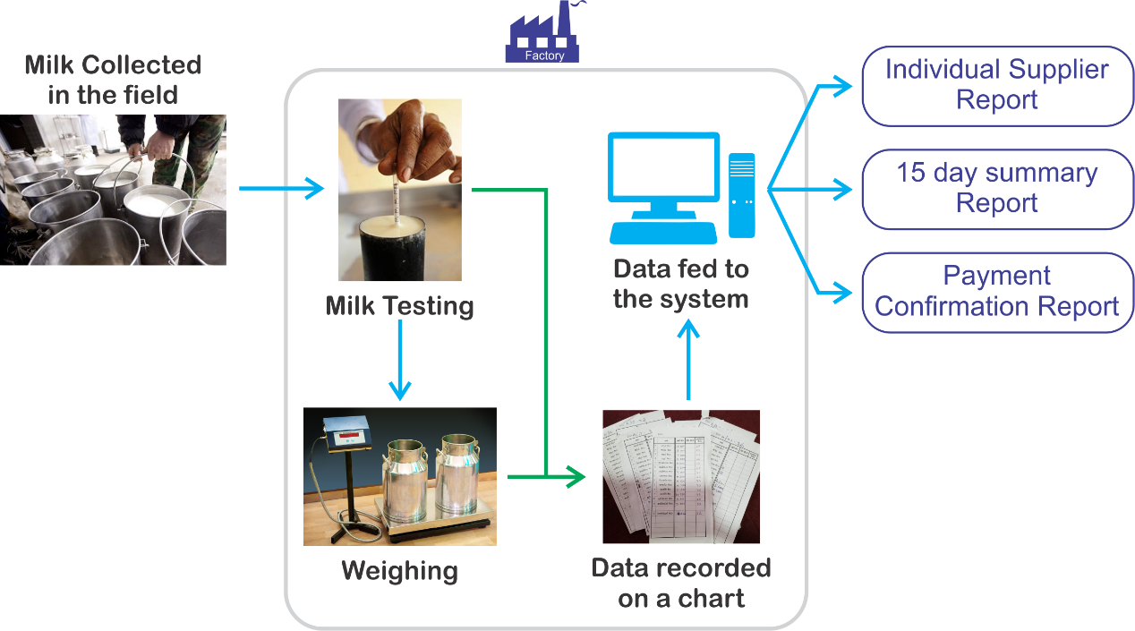

Figure 4 : Milk Collection Process

#### Supplier Management Module

This module can be accessed by anyone but only the admin level users can restore, view and access the supplier history. Milk supplier details are stored to the system via this module.

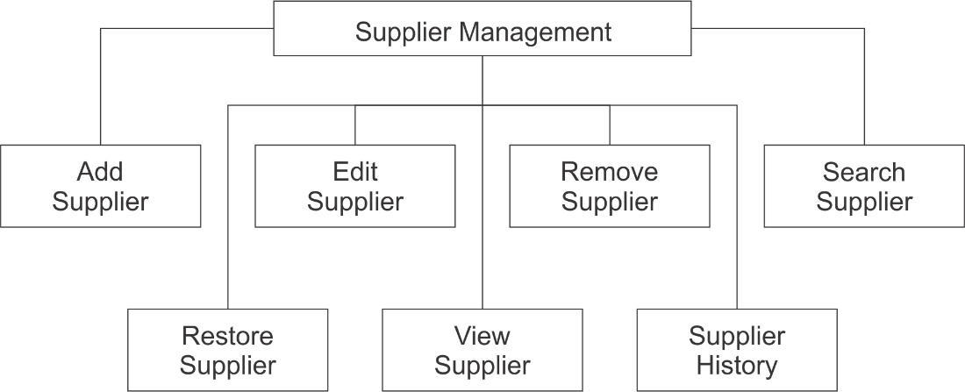

Figure 5: Supplier Management Module

#### Collection entry module

This module can be accessed by everyone from all levels. This module is used to maintain the milk collection records. This module is used to record the data from the daily collection table.

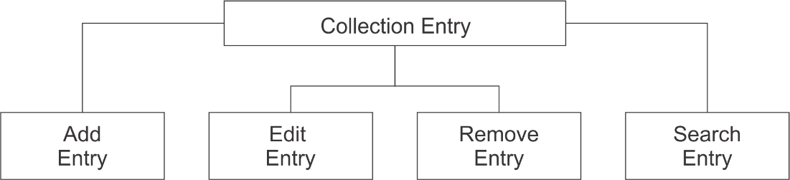

Figure 6: Collection entry module

### 1.3.2 Employee Management

Main part of the employee management is to record the daily admission times of the employees. Factory workers arrive and leave at varying times while having a midday short break. These times are recorded on a book and that data is fed to the system weekly. The system calculates the number of hours a worker has worked and calculates the salary according to the pay grade. The other classes of employees have their own pay grades; therefore, each class has their own calculation method and data entry interface. The system generates a pay sheet, and monthly reports at the end.

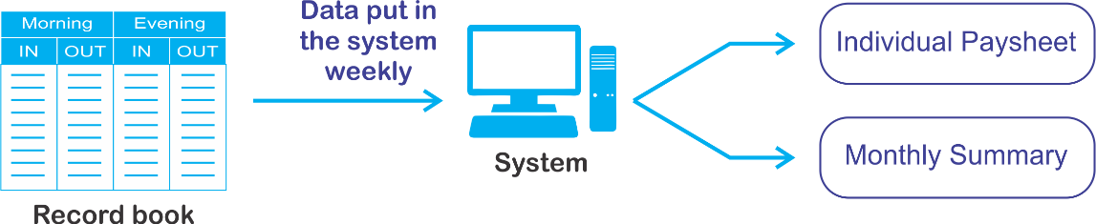

Figure 7: Class I employee salary calculation process

#### Employee Management Module

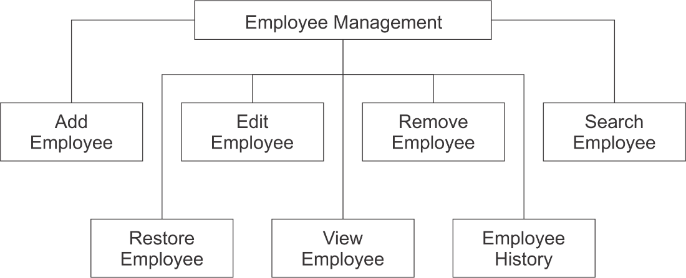

Figure 8: Employee Management Module

This module can be accessed by anyone but only the admin level users can restore, view and access the employee history. Employee details are stored to the system via this module.

#### Admission Record Module

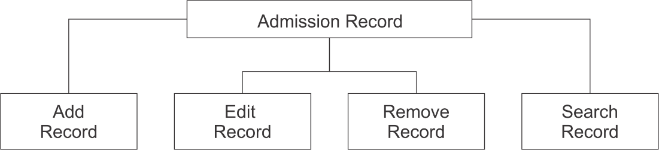

Figure 9: Admission Record

This module can be accessed by everyone from all levels. This module is used to maintain the employee admission records. This module is used to record the data from the daily admission record book.

### 1.3.3 Inventory Management

The system needs to record the purchases of goods/ items/ services in order to manage the production and make predictions. The goods/ items usually are sugar, fuel, packaging materials, polythene, gas and the services are electricity and water.

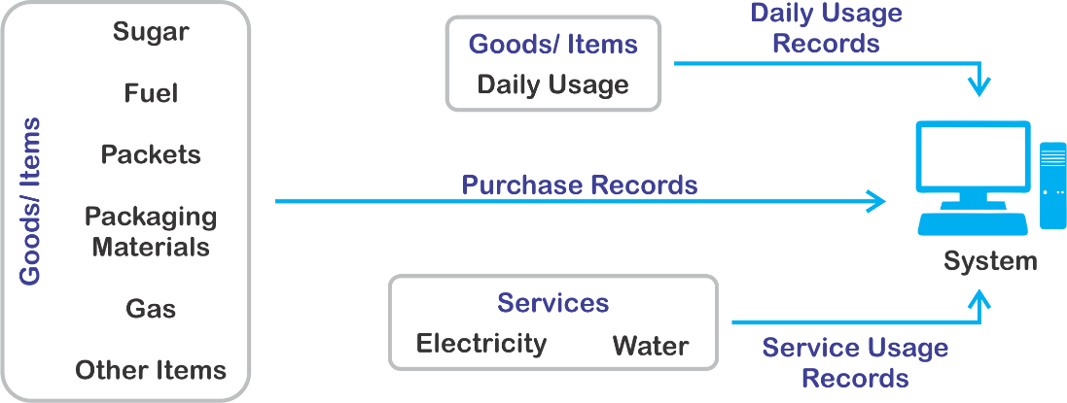

Figure 10: Inventory Management Process

#### Purchase Record Module

This module can be accessed by anyone but only the admin level users can view and access the purchase history. Purchase details are stored to the system via this module.

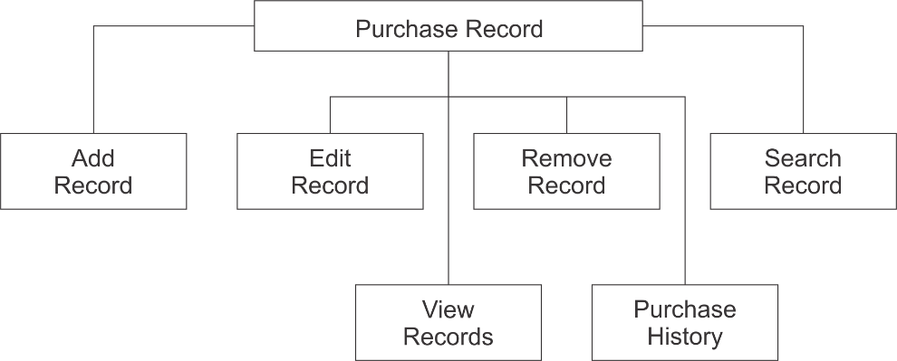

Figure 11: Purchase Record Module

#### Services Usage Record Module

This module can be accessed by anyone but only the admin level users can view and access the usage history. Services usage details are stored to the system via this module.

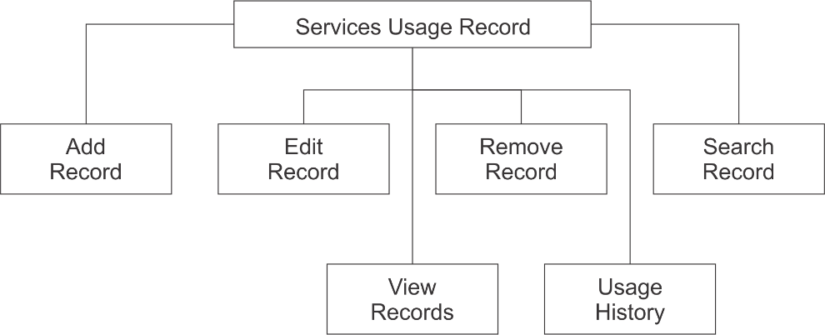

Figure 12: Usage Record Module

#### Daily Usage Record Module

This module can be accessed by anyone but only the admin level users can view and access the usage history. Daily usage details are stored to the system via this module.

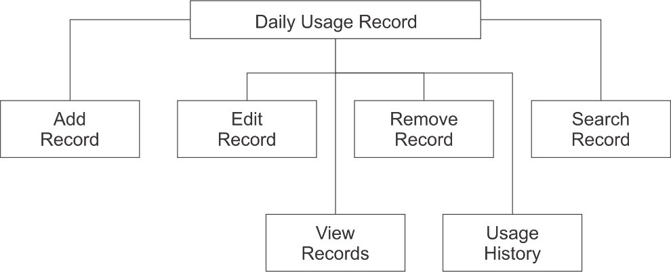

Figure 13: Daily Usage Record Module

### 1.3.4 Sales Tracking

#### Client Management Module

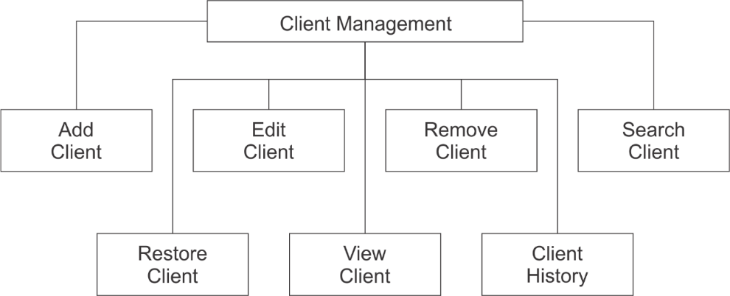

Figure 14: Client Management Module

This module can be accessed by anyone but only the admin level users can restore, view and access the client history.

#### Product Management Module

This module can be accessed by everyone from all levels. This module is used to maintain the product list.

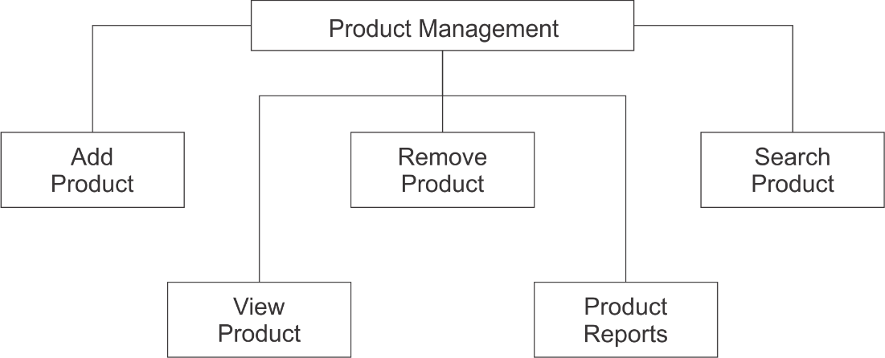

Figure 15: Product Management Module

#### Payment Module

Everything can add, edit, remove and view payment records but only the admin level users can view and generate payment reports.

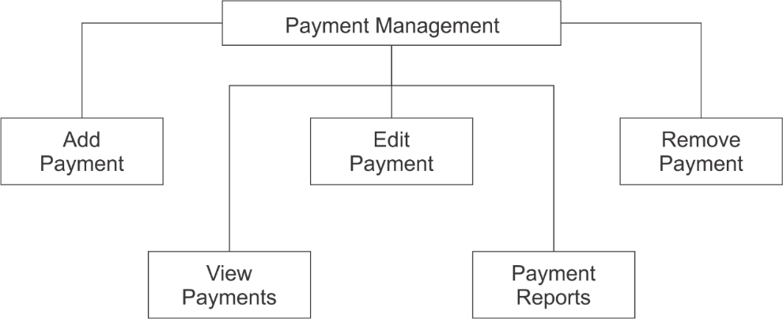

Figure 16: Payment Module

#### Invoice Management Module

This is one of the most advanced modules in the project.

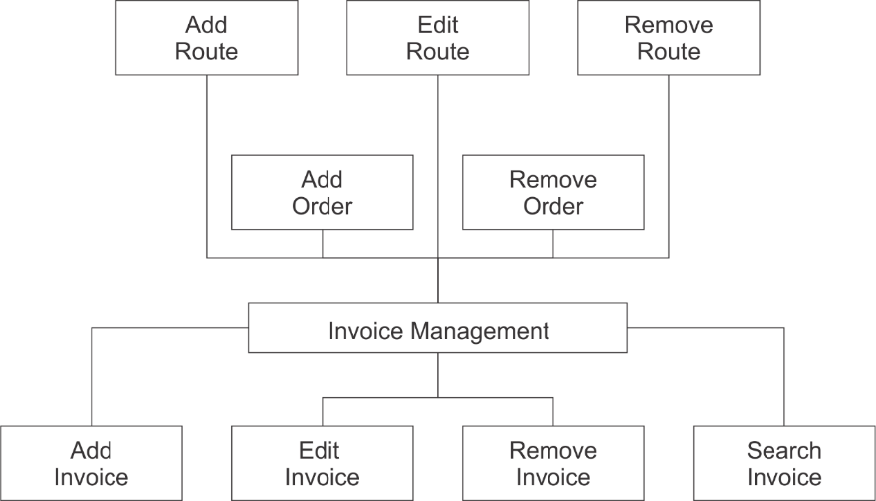

Figure 17: Invoice Management Module

This module is used to add, edit or remove routes which specifies the delivery route of the orders contained inside. Each route will have multiple orders on different dates holding multiple Order numbers. Each order will contain many invoices, which falls under the same order number but assigned for different clients. The database structure of this process is described later in the document. Removing an order is only available for the admin level user.

## 1.4 Project Schedule

Gantt Chart

## 1.5 Outline of approach / Methodology Used

The software/ services used for the development of the application is listed below (see Table 1). On the other hand, the methodology I used to develop this is waterfall model.

|  |  |
| --- | --- |
| **Software / Service** | **Purpose** |
| Visual Studio Code 1.44.2 | For front-end and back-end development using PHP, JavaScript, CSC and HTML |
| MySQL server 8.0 | Database service |
| JetBrains DataGrip 2018.2.5 | For MySQL server management and database manipulation |
| XAMPP Control Panel | For implementation of the local server |
| GitHub | Whole project is stored in GitHub for the ease of development |

Table 1: Software / Services used in development

Waterfall model is one of a system development life cycle (SDLC) model. Developer proceed to next phase if and only if the current phase is complete just like water in a waterfall always fall down, but never goes upward. In Royce's original waterfall model, it originally consisted of 7 phases which are Requirement Specification, Design, Construction, Integration, Testing and Debugging, Installation and Maintenance.

First, I visited the said company and discussed and understood the requirements of the application while taking input from the clients and integrating them with my opinions and ideas. After a sufficient requirement speciation is constructed, the next phase is the design phase.

This consists of user interface design and database design. The interface design is somewhat challenging because as per the requirement specification, the application has to replace the existing management models used in the company with least modifications, thus making it easier for the company to assign existing clerks and managers to use the application with a very small training curve. Database design was straightforward once the requirements are analyzed carefully.

Next, the construction phase was one of the most important and time-consuming phases given the programmer's abilities. The programmer's experience in web development was fairly new, thus causing considerable amount of time although the logic and the processes of the application was well understood.

The integration phase was for integrating the UI with the database. A mobile application was suggested before in the design phase but it was dropped later in the integration process.

After the integration came the testing and debugging phase. For testing module, it is separated into few types which are module testing, system testing, unit testing and user acceptance test. Once there is a bug found, it was immediately fixed/ solved before the system is launched in order to ensure the launched system is bug free.

Lastly, the system was initiated on a public server and the database had to be populated with existing data in order to speed up the learning process. After the initialization, the system maintenance is constant requirement since this is a web application and the communication between the browser and server can sometimes not work as expected.

In my opinion, the time spent on earlier phases of SDLC can lead to greater economy in later stages. In earlier phases, a bug can be fixed in short time with less cost and much flexibility and less effort compared to later phases.

### 1.5.1 Development Environment

#### Software

##### Operating System: Windows 10

##### Database: MySQL

MySQL is an open-source relational database management system.

##### Development tools and programming languages

Visual Studio Code: Visual Studio Code is a source-code editor developed by Microsoft. It includes embedded Git and support for debugging, syntax highlighting, intelligent code completion, snippets, and code refactoring.

XAMPP: XAMPP is a free and open-source cross-platform web server solution stack package, consisting mainly of the Apache HTTP Server, MariaDB database, and interpreters for scripts written in the PHP and Perl programming languages.

GitHub: GitHub is a Git repository hosting service, but it adds many of its own features. While Git is a command line tool, GitHub provides a Web-based graphical interface. It also provides access control and several collaboration features, such as a wikis and basic task management tools for every project.

HTML: Hypertext Markup Language is the standard markup language for documents designed to be displayed in a web browser. It can be assisted by technologies such as Cascading Style Sheets and scripting languages such as JavaScript.

PHP: PHP is a popular general-purpose scripting language that is especially suited to web development.

JavaScript: JavaScript, often abbreviated as JS, is a programming language that conforms to the ECMAScript specification. JavaScript is high-level, often just-in-time compiled, and multi-paradigm. It has curly-bracket syntax, dynamic typing, prototype-based object-orientation, and first-class functions.

CSS: Cascading Style Sheets is a style sheet language used for describing the presentation of a document written in a markup language like HTML. CSS is a cornerstone technology of the World Wide Web, alongside HTML and JavaScript

##### Hardware

##### Processor

Intel Core i5-6200U

##### Ram

8 GB

## 1.6 Operation Environment

Since this application runs in the web browser, the minimum requirements for the application are similar to the requirements of a latest web browser. Chrome web browser is suggested for using the application.

Google Chrome will run on computers equipped with a Pentium 4 processor or higher, which encompasses most machines manufactured since 2001. The computer must have approximately 100MB of free hard drive space and 128MB of RAM.

An internet connection is required to access the web application.

## 1.7 Chapter 1 Conclusion

In chapter 1, the project background, project schedule, project scope, methodology used and the development and operating environment are discussed.

Since this application was developed for a target company, some minor problems had to be faced during the system planning because the developer did not have total freedom in deciding how the system should work. Therefore, the system has some company specific functionalities which are not common among other similar applications.

Although the waterfall model was used, it caused some problems while integrating the user interface with the backend of the system due to poor coding practices. Therefore, the communication linkage had to be modified along with the back-end development process.

Making some necessary changes and modifications are suggested during the development process without just blindly following the chosen methodology in order to ease the process while minimizing the error.